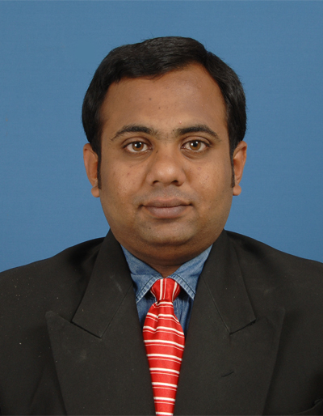
No2, Indhumanagar,
V.K Rd, Peelamedu,
Coimbatore-35,
98403-80444
rushianand@gmail.com

Rushi Anand.V
______________________________________________________________________________

SYNOPSIS____________________________________________________________________

An MBA in HR & MKT presently working as Freelance Soft Skill Trainer & Corporate Trainer for more than two and half year, have experience of three years as a Project Trainee and one year as an Event Manager.

Self motivated individual with excellent communication and interpersonal skills

WORK EXPERINCE:___________________________________________________________

- 2013-Presently working as Freelance Soft Skill Trainer/Corporate Trainer.

Role:
Imparted training programs across various industries like Event Management, Retail, Information Technology, and Engineering and Arts & Science colleges at all levels in India. Trained Client employees and students on Presentation Skills, Business Communication, Business Etiquette, Team Building, Time Management, Negotiation Skills, Selling Skills, Customer Relationship Management, Leadership & Motivation, Interviewing Skills, HRM Topics, etc and also conducts training needs analysis & designs learning solutions.

Partial list of clients trained for:

- ADECCO.
- TALENT SPRINT
- SILVER TOUNGE.
- LIDAR.
- LAUNCH PAD LLC.
- ICICI Academy for Skills.
- GRAMMER BOX.
- TONY & TONY ASSOCIATES.
- RAZZMATAZZ GROUP.
- RED & WHITE EVENTS.
- VIRTUEZ 360 DEGREES.
- SIMERF.
- HARI JEWELLERY DESIGNERS.
- DANUSH TEX TADERS.
- SIVASARAVANA CHIT FUNDS PVT LTD.

- 2010-2012(25\11\2012) worked as a Project Trainee in SIDHAMARG INSTITUTE OF MANAGEMENT AND RESEARCH FOUNDATION (SIMERF)

Role:
Coordinated and assisted in the implementation of training programs offered by the company to the clients, general administration work, banking, infra-structure purchase, maintenance along with monitoring minor staff duties, developing marketing aids, maintenance of appropriate communication, starting from initial presentations, literature & relationship building with the prospective clients about company’s services.

- 2009-2010 worked as Event Manager

Role:
Involved in development, planning, budgeting, promotion and execution of events with mass attendance involving multiple partners/vendors and huge budgets.
Worked in conducting brand launches, innovative promotional schemes, devising brand building activities, conducting promotional campaigns and accelerating the business growth.

EDUCATIONAL QUALIFICATION: _____________________

Professional Qualification:

PARTICULARS | COURSE | YEAR | CLASS
Indian Institute Of Planning And Management (IIPM), Chennai. | MBA  (Integrated)  (HR&MKT) | 2012 | FIRST CLASS

- Attended Advanced Global Management Program at McCombs School of Business in University of Texas, USA.
- Attended “Global Opportunities and Threat Analysis program” at Nanyang University, Singapore.
- Thesis on Measurement of brand awareness and brand perception

Academic Qualification:

PARTICULARS | CLASS | YEAR | CLASS
RR higher secondary school | SSLC | 2005 | FIRST CLASS
Vetri Vikass Higher secondary school | HSC | 2007 | FIRSTCLASS

HOBBIES: ____________________________________________________________________

- Travelling
- Exploring
- Listening to music
- Read comics
- Watching movies

LINGUIST PROFICIENCY:_____________________________________________________

English, Tamil & Telugu

PERSONAL DETAILS: _________________________________________________________

Date of Birth : 15th June 1989
Gender : Male
Marital status : Single
Father’s name : N.Vijayakumar

DECLARATION_______________________________________________________________

Here by, I declare that all the information provided above is correct to the best of my knowledge.

Place: Coimbatore

Date:

V. Rushi Anand

